|  |  |  |
| --- | --- | --- |
|  | **ST. FRANCIS INSTITUTE OF TECHNOLOGY**  **Mount Poinsur, Borivali (West), Mumbai-400103**  **Department of Information Technology**  **Information Technology Students’ Association (ITSA)**  ***ITSA’s Ethical Hacking and Cybersecurity***  ethical hacking poster2.png |  |
|  | • Date: -9th March 2021  • Time: -5:30 p.m.-7:00p.m.  • Platform: -Google Meet  • No. of Participants:- 80 |  |

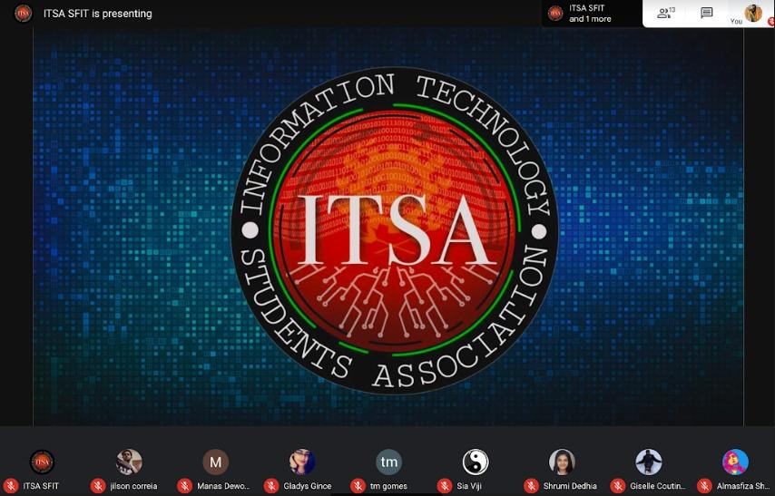

After the Debate Competition ITSA was up with the next event on Ethical Hacking. This workshop on Ethical Hacking took place on March 9, 2021, via Google Meet. The resource people for the same were Mr. Sachin Dedhia and Ms.Priya Savla. Mr.Sachin Dedhia is an independent Cybercrime Investigator & also a Certified Ethical Hacker.

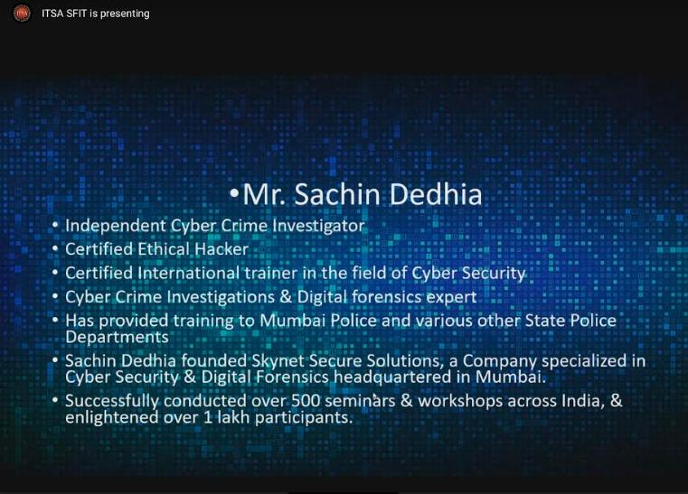

Our technical executive, Mr. Viral Soni introduced Mr. Sachin Dedhia, welcomed everyone present in the meet, and started the workshop by giving a short introduction about himself. He also gave an introduction about different certifications and degrees in the same field, mentioned that there is a difference between being a hacker and being an ethical hacker. Asked the participants if they want to be a Hacker or an Ethical Hacker and what would they hack if they become one? There were many responses to this question given by the students.

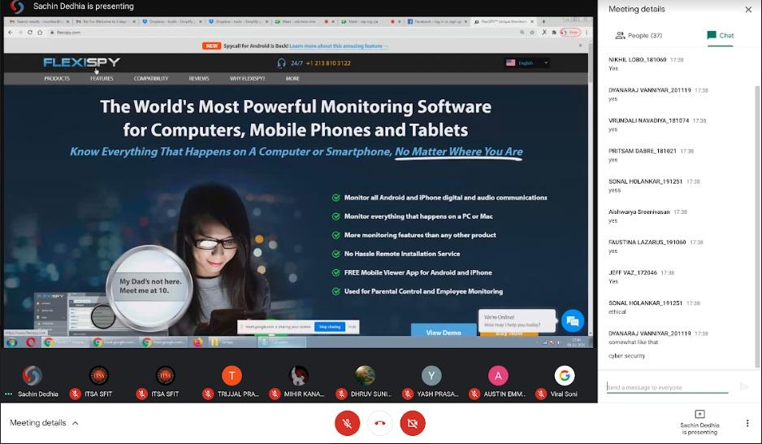

The objectives of this Workshop:

* Careers in Cyber security
* Cyber security fundamentals
* Mobile hacking & security
* Social Media frauds & security
* Personal data protection

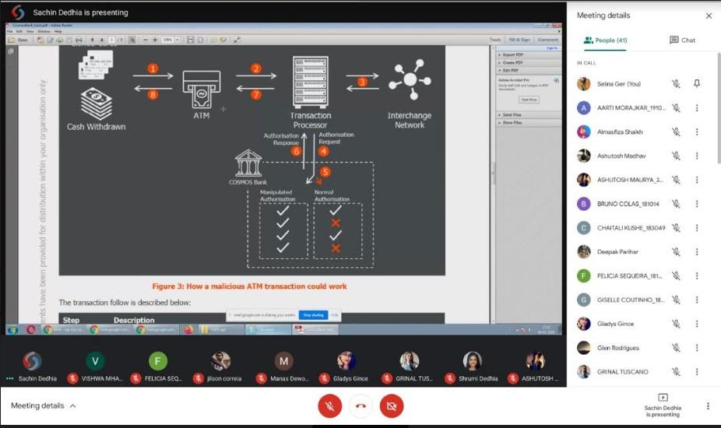

Mr.Sachin Dedhia said that now-a-days information of servers and sites are not being hacked instead mobile phones are being hacked as they contain most of the information about us. He told us about the application used to hack android mobile phone which is FLEXISPY and explained its features, how it works. He discussed the case study of the Cosmos Bank Fraud how the system was actually hacked and maximum money was withdrawn within limited time frame. Showed a website i.e. FORTINET where we can see live cyber-attacks happening around the world. Practically showed us how to hack passwords easily, gave information about last activity view tool used to view the person’s activity logs which collects information from our device through applications we use such as Facebook.

At the end of the session few doubts of the students were cleared also why one should choose this stream and how important it is was explained very well. Mr Sachin Dedhia thanked the organizers for inviting and the participants. Felicia Sequeira, the PR head concluded the workshop by giving a vote of thanks.

Participants found this workshop very informative and useful. Everyone gained basic knowledge based on present cyber-attacks and hacking.

|  |  |  |
| --- | --- | --- |
| **Mrs. Shree Jaswal** | **Mrs. Grinal Tuscano** | **Dr. Joanne Gomes** |
| **(ITSA Co-ordinator)** | **(ITSA Co-ordinator)** | **(HOD-INFT)** |